DAROFF-DELL’OSSO OCULAR MOTILITY LABORATORY (DD_OMLAB)
LOUIS STOKES CLEVELAND DEPARTMENT OF VETERANS AFFAIRS MEDICAL CENTER
CASE School of Medicine
10701 East Boulevard Mail Code #151W
Cleveland, OH 44106, USA
Phone: (216) 421-3224
Fax: (216) 231-3461
Website: http://www.omlab.org
Note: Information from this page contains no medical advice.
You should always consult your doctor about INS treatments.
This document was created by Z. I. Wang and edited by Dr. L.F. Dell’Osso.
Note: In this document, we have presented very complex scientific information in laymen’s terms.

DD_OMLAB Patient Information Series:
2. INFANTILE NYSTAGMUS TREATMENTS

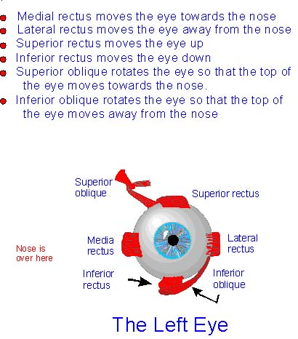
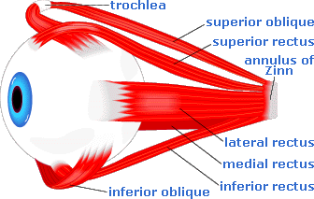
Medial
rectus
Lateral
rectus

Eyeball in a side view
Eyeball in a front view

- How do our eyes move?
Each eyeball has 6 eye muscles around it, moving it as the brain directs it to go. In the Figure above, you can see the eyeball in a side view and front view. The lateral and medial recti (circled in the Figure) are the two eye muscles that control the left-and-right eye movements of each eyeball (it makes sense since they are placed on the left and right of the eyeball). Imagine a pair of tight rubber bands that are fixed to a ball. When you pull one rubber band and relax the other, the ball will turn to one side. This is exactly what the brain directs the eye muscles to do to move your eyes.

- Can INS be cured? What are the goals for nystagmus treatments?
Right now Infantile Nystagmus [nĭ-STAG-muss] Syndrome (INS) cannot be cured but can be helped. The current treatments for INS correct head turns (if any) and improve visual function (you may see better, have a broader good-vision field, and see faster). Also nystagmus treatments may result in cosmetic improvement; your eyes may wiggle less. The effects of treatments are different from person to person. You first should have your eye movements recorded, so that your doctor knows what type/types of nystagmus you have, which surgery to perform, and how much improvement you should expect from the surgery.

- What is a “Null Point”?
A “null point” in INS means the visual angle where you see best. The null point can be on the left, right, up or down side of your visual field. In order to use your null point, you usually turn or tilt your head to one side to see an object directly in front of you. Although most INS patients have a null point, there are some who do not. Some may have a null point that changes with time.

- What does the Anderson-Kestenbaum (AK) surgery do? Is the improvement permanent?
The Anderson-Kestenbaum (AK) surgery involves cutting and moving the eye muscles so that you can make use of your null point when you look straight ahead. For example, if your null point is on the right, the AK surgery will be done so that both eyes will be moved to the left (the eyes will not look like they are squinted, though). Once that is done, when you look straight ahead, your eyes will be in your null point. This surgery may eliminate your head turn. Also, your good-vision field may be broader, and you may see faster.
AK is a simple, outpatient surgery. The key to a successful AK surgery is to find out how much the eye muscles should be moved. Eye-movement recordings are necessary for the doctors to find that information accurately. If the AK surgery is done properly, the effects will last.
Base-left or base-right prisms can be added to your glasses to help you make use of your null point too. You might not get the “broadened, good-vision-field” effect though.

- Will strabismus be corrected?
Strabismus [stra-BIZZ-muss], or squint/lazy eye, often happens together with INS. Strabismus can also be corrected along with the AK surgery. The doctors need to make an adjustment to the amount of movement of each eye muscle. Again, they can find that information in your eye-movement recordings.

- What does the Bimedial Recession (BMR) surgery do?
If you have a “convergence null”, you see better when you look at something near (as when you are reading a book). BMR (also called, “artificial divergence”) surgery can help you in this case. This surgery moves your eye muscles so that your eyes will be “converged” even when looking at a distant object. For example, you may not have to hold the book close to see it well; you may see it as well at a distance. Also, your good-vision field may be broader.
BMR is a simple, outpatient surgery. We usually recommend that your eye doctor prescribe some base-out prisms before the surgery. These prisms function the same as the surgery, and you can try it to get a feel for how well you tolerate it and how much better you may see after the surgery. Please note that you need to have good stereoscopic vision (3-D vision) to be a candidate for this surgery. If you have strabismus, BMR will not help your INS.

- What non-surgical treatments have been reported to be effective?
Prisms can be used as an alternative to the AK and BMR surgeries, as mentioned before. Contact lenses may reduce your nystagmus too, and they may give you a broader field of good vision.
Researchers also have found several other non-traditional ways to improve the nystagmus: blowing air to your forehead, vibrating your neck muscle, ear acupuncture and so on. Unlike surgeries, these methods have temporary effects. As soon as you stop them, your nystagmus will go back to the same as before.
Some drugs (for example, Mamentine) have proven to be useful to improve the nystagmus. The long-term effects of these drugs are unknown right now.

